Class row –

This class is used to divide rows.

Class col –

This class is used to divide columns. In bootstrap there are 12 columns already. We can use those 12 cols for our purposes. As an example, think we want three cols in our page. So we can use 4 cols each from those 12 cols.

Consider this example-

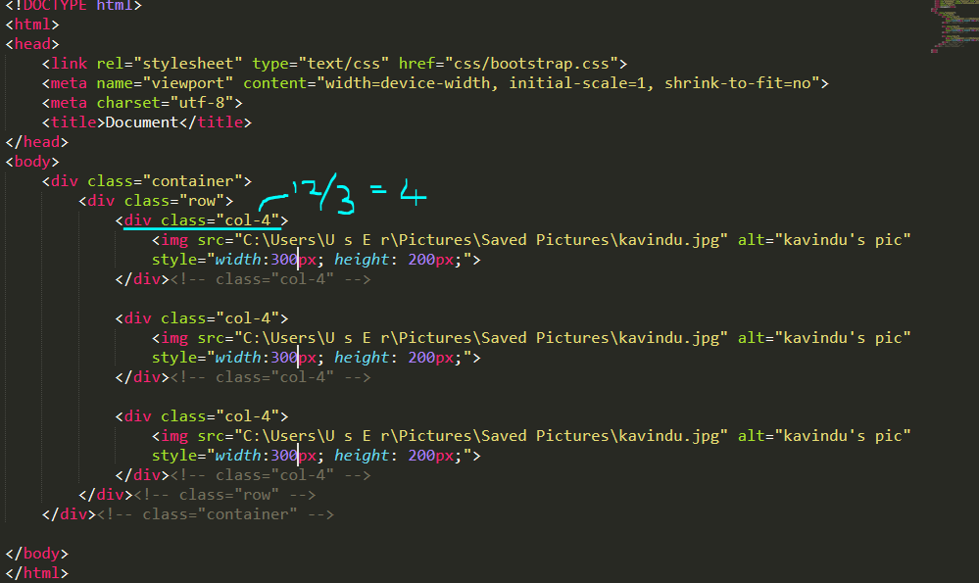

Outcome-



